CARFINDER APPLICATION

EXPLAIN THE PROGRAM:

This application provides us who want to know something about the car,he or she handles it.Such as you want to know a car’s horsepower,torque and engine you can achieve it by this application.

Requirements:

When the user enter the program he or she faces with a page,ın this page he or she able to save some cars or can search some cars if he or she wants.

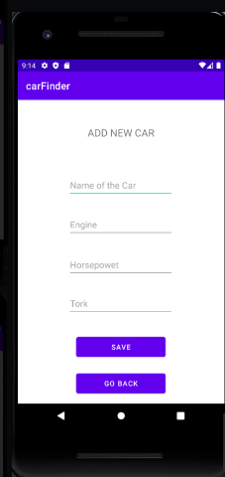

Then he or she will face with the some informations about the car.

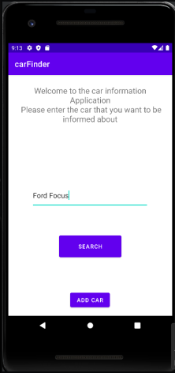

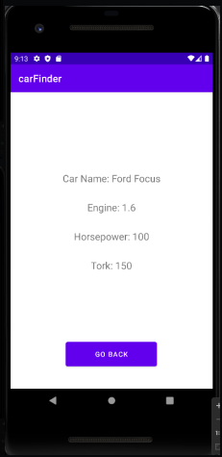

In here we can see the informations about the Ford FOCUS.